**The impact of periodic presumptive treatment of sexually transmitted infections on HIV incidence in Papua New Guinea**

Christopher Rock

Supervised by John Murray and Richard Gray

The University of New South Wales

# Acknowledgements

The author thanks Andrew Vallely and David Wilson for providing insight and feedback on our assumptions and parameter values.

# Abstract

Papua New Guinea (PNG) has one of the highest rates of HIV in the Asia-Pacific region (WR). Some sexually transmitted infections (STIs) with high prevalences in PNG, especially ulcerating STIs, increase the odds of transmitting or receiving HIV. Any reduction in the prevalence of these ulcerating STIs will cause a reduction in HIV transmission and susceptibility, and thus reduce the *incidence*, or number of new cases,of HIV. One intervention which may reduce levels of specifically of ulcerating bacterial STIs achieve this is *periodic presumptive treatment* (PPT) of a selection of STIs, where a suite of drugs which cure these STIs are provided on a regular basis to the population, without testing for those STIs first. Lowering other STI prevalences would provide direct benefits to the population, but this paper considers the effect of PPT on HIV prevalences.

We built a simple model for a particular class of STIs, *ulcerating bacterial STIs* (UBSTIs), to model the effects of PPT on these STIs in Papua New Guinea. We used an existing model (Gray, Murray et al. 2011) to model the effect on HIV of such a decrease in STIs. Our model has three main outcomes: forecasted decrease in STI prevalence after 3 years, forecasted decrease in STI prevalence after 10 years, and decrease in HIV incidence after ten years.

# Introduction

Papua New Guinea is a developing island nation of 3.8 million people directly north of Australia. There were approximately 32,000 people living with HIV in Papua New Guinea in 2013, according to (AIDSinfo 2014), with a prevalence of 0.5%. AIDSinfo data indicates that HIV prevalence increased sharply

STIs can be broadly divided into ulcerating and non-ulcerating STIs. Ulcerating STIs create openings in the defensive layers of skin which normally form a barrier against pathogens. This greatly increases the chance that a pathogen such as HIV will enter the body. (WR – John, you showed me a journal article with a diagram of the skin, could you find that again?) Thus, ulcerating STIs greatly increase the probability of contracting HIV from an infected partner. The most prevalent ulcerating STIs in PNG are HSV-2 (prevalence WR), syphilis (prevalence WR), and (…) .

There is some evidence that HIV affects the disease progression of certain USTIs. For example, it may accelerate syphilis progression, and/or increase the probability of a false negative test. However, these effects have by and large not been confirmed in large observational studies (Pialoux and al 2008). We ignore any interaction between HIV and USTIs other than USTIs increasing the probability of transmitting HIV.

STIs can also be divided into bacterial and viral STIs. Bacterial STIs are generally curable with antibiotics. Syphilis in particular is very vulnerable to the antibiotic penicillin G benzathine, while … . However, viral STIs, such as HSV-2 and HIV itself, are not curable with medication, although medication can be used to suppress symptoms (WR WR). If PPT were implemented, it is likely that a combination of drugs would be provided to treat a range of both ulcerating and non-ulcerating STIs. While enough data exist for us to implement a model which tracks individual STIs rather than categories of STI, this is beyond the scope of this paper.

# Methods

## Definitions

|  |  |
| --- | --- |
| Term or abbreviation | Definition |
| FSW | Female sex workers |
| MSMW | Men who have sex with men and women |
| Incidence (of a disease per unit time) | Number of new cases of that disease in that time |
| Prevalence (of a disease) | Proportion of people who have that disease |
| PNG | Papua New Guinea |
| Sub-populations | General males, MSMW, general females and FSW |

### General outline

We created a model in three parts. Firstly, we fixed the starting level of UBSTIs, and defined how we will convert between UBSTI and USTI prevalences. , Secondly, we built a model for UBSTIs to assess the impact of PPT on the prevalence of UBSTIs, ignoring the effect of other STIs on UBSTI transmission. Lastly, we inputted these modelled prevalences of USTIs into the HIV model, to assess the impact of PPT on HIV.

All parts of the model were deterministic and compartmental. The HIV model divided the PNG population into general males, men who have sex with men and women (MSMW), general females and female sex workers (FSW), and the UBSTI model did likewise. The HIV model further distinguished between two regions which can be interpreted as urban and rural. The UBSTI model did not explicitly include this information, but for every run of the HIV model, we ran the UBSTI model once for the urban population and once for the rural population, keeping everything else constant but changing the UBSTI starting rates.

## Conversion between USTI and UBSTI prevalences

Our formula for converting between USTIs and UBSTIs had two parts. Firstly, we took the prevalences of USTIs from (Gray, Murray et al. 2011), and estimated the fractions and of these infected people who had UBSTIs and UVSTIs, respectively. We estimated at 0.50 and at 0.67. This gave us our starting UBSTI prevalence.

|  |  |
| --- | --- |
|  | Equation |

For each model run, we inputted the starting prevalences of UBSTIs into out UBSTI model, and received a time series of UBSTI estimates. We assumed that UVSTIs would remain constant. We also assumed that the probability that a person with a UVSTI would have a UBSTI with probability proportional to the prevalence of UBSTIs. To calculate the time series of prevalence data for USTIs, we calculated the probability a person with a UVSTI would have a UBSTI, as a function of the UBSTI prevalence, then applied that function at each time step. That is, letting denote the prevalence of USTIs, denote the prevalence of UBSTIs and denote the prevalence of UVSTIs, we assumed:

|  |  |
| --- | --- |
|  | Equation |

Here, is the probability that at once the intervention has started and the prevalence of UBSTIs has fallen to , a person with a UVSTI also has a UBSTI. We present our estimates for USTI levels in the table below:

|  |  |  |  |  |
| --- | --- | --- | --- | --- |
| Sub-population |  |  |  |  |
| Prevalence of USTIs assuming no PPT | Prevalence of UBSTIs assuming no PPT | Prevalence of UVSTIs assuming no PPT |  |
| Rural FSW | 0.07 | 0.04 | 0.05 |  |
| Rural general females | 0.08 | 0.04 | 0.05 |  |
| Rural general males | 0.09 | 0.05 | 0.06 |  |
| Rural MSMW | 0.32 | 0.16 | 0.21 |  |
| Urban FSW | 0.05 | 0.03 | 0.03 |  |
| Urban general females | 0.06 | 0.03 | 0.04 |  |
| Urban general males | 0.07 | 0.04 | 0.05 |  |
| Urban MSMW | 0.30 | 0.15 | 0.20 |  |

## HIV model

For our model of HIV, we use the model from (Gray, Murray et al. 2011), with some modifications. This model uses the period from 1990 to 2010 as a calibration period, then predicts HIV levels under various intervention strategies.

Between 2011 and this paper’s release date, new data became available, causing us to revise some parameters into line with current research. In particular, as HIV clinics spread into more areas, lower levels of HIV were discovered. Initially, all of the clinics in PNG were in high-risk areas such as Port Moresby and (suggestion?). This data was then extrapolated across the country. Later, clinics also opened in areas with lower prevalences, such as (suggestion?). Also, many people would have travelled to reach clinics, and would have been more likely to make the trip if they suspected they were infected. As more clinics opened and the distance people need to travel decreased, people would have needed less incentive to visit clinics, and more people who did not think they were infected would have visited a clinic.

This made more recent data more representative of the actual prevalences. We thus assumed that HIV prevalence did not peak at 0.9% and then fall to current levels, but that it remained below the older estimates, and remained steady when the estimated prevalence fell. We have also found that the STI cofactor used in the model was at the top of its confidence band. We have re-fitted the model to a lower STI cofactor.

We re-fitted the model by varying the baseline transmission probabilities, average numbers of sex acts per partner and diagnosis and treatment rates for people with HIV.

The model accounts for USTIs by allowing the user to specify a single time series of USTI prevalences for each sub-population. The model increases the HIV transmission probability by a cofactor if either partner has a USTI. This prevalence is held constant during the calibration, and then allowed to vary during the intervention projection. This varying rate during the intervention is how we inputted the USTI prevalence.

## UBSTI model

### General description

We built a deterministic compartmental model in discrete time. We split the population into four sub-populations: general males, men who have sex with men and women (MSMW), general females, and female sex workers (FSW). When the intervention began, we further split the population into people participating in the intervention and people not participating in the intervention. At any time step , a member of any sub-population could be either susceptible or infected. If that population was undergoing PPT, that member could also be in an additional state, protected by PPT (). While a person was protected by PPT, we assumed they cannot develop UBSTIs.

Our model contained a set of fitted parameters which allowed us to calibrate our model in the baseline case to the levels already in use in the HIV model. No population was undergoing PPT in the baseline case, so every population contains only susceptible and infected members. Thus, we only require four fitted parameters to specify our equilibrium.

We run two instances of our model per scenario, one for each region as defined by the HIV model, and we do not allow interaction between regions in our UBSTI model.

Our model uses a system of difference equations for the proportions of each sub-population that are susceptible, infected or protected. These equations are identical in structure between FSW, general females and general males. They differ for MSMW in that the infection rate depends on UBSTI prevalences in three populations instead of two.

The equations for FSW are:

|  |  |  |  |
| --- | --- | --- | --- |
| Parameter | Description | Typical value[1] |  |
|  | Proportion of FSW who are susceptible | 0.7809 |  |
|  | Proportion of FSW who are infected | 0.2128 |  |
|  | Proportion of FSW who have acquired resistance because of presumptive treatment (see note) | 0.0063 |  |
|  | Infection rate for FSW (see below) | 0.0109 |  |
|  | PPT rate for FSW (as adjusted, see below) | 0.0078 |  |
|  | Treatment and loss parameter | 1.2 | (WR) |
|  | Time step |  |  |
|  |  |  |  |
|  |  | 1/122 |  |

We assume that no-one receives PPT immediately after they lose their resistance, so they become susceptible immediately after they become susceptible. They then have the same probabilities of remaining susceptible or becoming infected by time as the rest of the susceptible people at time , except that the people who were protected at time have no probability of becoming protected at time .

We provide a diagram of the possible state changes, and describe the physical meaning of each state change, in the Appendix (Figure ??).

The main equations for the other sub-populations are identical to these, except that every value with a subscript is replaced by a different value with a different subscript or . In our typical scenario, no sub-population other than FSW has PPT, so all other and are 0.

### PPT rate equation

The PPT rate is estimated as:

|  |  |  |  |
| --- | --- | --- | --- |
|  | Coverage of PPT for FSW | 0.75 | Andrew (WR) |
|  | Average number of visits per year, for a person on PPT | 4 | Andrew (WR) |
|  | Initial effectiveness of PPT | 0.98 | (WR) |
|  | Increase in resistance to PPT of STI | 0.01 | (WR) |
|  | Half-life of PPT protection | 3 | (WR) |

### Force of infection equation

The force of infection, and , are defined as follows:

This contains further parameters, as outlined below:

|  |  |  |  |
| --- | --- | --- | --- |
| Sub-population |  |  |  |
| Assumed baseline level of syphilis | Infection rate | Infection rate fitted parameter (see below) |
| FSW | 0.0469 | 0.0027 | -6.954 |
| General females | 0.0536 | 0.0006 | -1.635 |
| General males | 0.0603 | 0.0005 | -0.500 |
| MSMW | 0.2144 | 0.0005 | -0.171 |

|  |  |  |  |
| --- | --- | --- | --- |
|  | Weight placed on level of infection in general females | 0.62 | (Gray, Murray et al. 2011) |
|  | Weight placed on level of infection in general males | 0.96 | (Gray, Murray et al. 2011) |

is the CDF of an exponential random variable with rate , evaluated at .

Note that is much lower than the proportion of females who are general females because each FSW contributes more to each male’s infection probability than each general female contributes. In contrast is the proportion of males who are general males because general males and MSMW are assumed to contribute equally to each female’s probability of infection.

### Calibration parameters

We require our syphilis model to satisfy four equations for the equilibrium level of syphilis in each of the four sub-populations, so that in the baseline scenario, syphilis levels remain at those already selected for the HIV model. We thus include four fitted parameters, and , which we calculate by solving the four equations for the equilibrium syphilis levels. That is, we find values for and such that

where each is a function of the corresponding , and on the values. We perform these steps once for urban populations and again for rural populations in each simulation, but we do not allow for movement between regions in this model.

## Results

Figure 1 shows that the projected impact of our default intervention (75% of FSW reached every 6 months) has a significant impact on HIV incidence. Increasing coverage or proportion of the population reached increases the effect size.

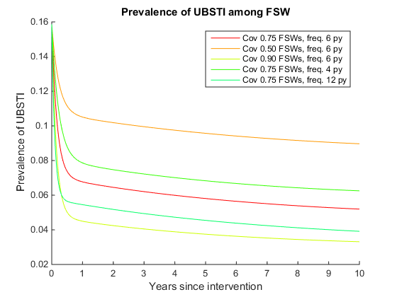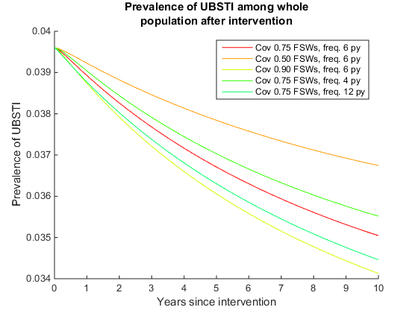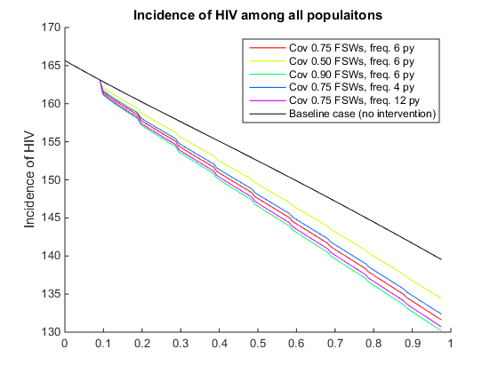

Figure 1: Projected impact of PPT on (a) prevalence of UBSTIs among FSW (b) prevalence of UBSTIs among whole population (c) incidence of HIV among whole population

### Sensitivity

The effect on HIV incidence is most sensitive to the parameters \psi and \gamma. When \psi increases by 10%, as can be seen in Supplementary Figure _, the projected impact on HIV incidence falls by 20%. When \gamma decreases by 10%, the projected impact falls by between 1.5% and 3%, falling more in the scenarios with larger impact size. All parameters with a smaller effect size are shown in Supplementary Figure _.

## Alternative interventions

If 10% of the PPT recipients are MSMW and 90% are FSW, holding the total number of recipients constant, the impact of the intervention on HIV incidence falls by between 6% and 10%. If 10% of the PPT recipients are general females and 90% are FSW, without increasing the number of recipients, the impact on HIV incidence falls by between 8.5% and 12%.

# Discussion

In this paper, we consider the impact of several possible PPT interventions among FSW in PNG. Our analysis has several limitations.

* No migration, FSW stop/start, etc.
* Homogenous mixing
  + Mitigated by the fact we are considering FSW, rather than the general population. Since each FSW is already assumed to have a large number of sex partners, it is essentially impossible for any individual to exceed our estimates by an extreme factor.
* Separate HIV and UBSTI models
* Do not consider details of UBSTI disease progression
* Not stochastic
* Critical dependency on total STI levels (can model additive STIs using phi+psi=1?)
  + The HIV model we used was designed without any explicitly fitted parameters, which are necessary for us to perform a reasonable sensitivity analysis on the overall USTI levels. Varying these parameters caused the HIV model to return HIV levels which were unrealistic. Our model did allow us to change the proportion of the USTIs which are UBSTIs, so that we could observe the sensitivity of the impact on UBSTI prevalence to the initial UBSTI levels, but we cannot then convert this impact into an impact on HIV incidence, *because a decrease in UBSTI incidence not matched by an increase in UVSTI incidence would decrease how much of the ?*
* No data on change in STI prevalence over time

These results suggest it is reasonably hard to achieve a significant decrease in HIV incidence using PPT. This effect takes a moderately long time to develop. In particular, reducing HIV at a population level depends on most FSW participating in the intervention. _Parameters

The model is not very sensitive to the duration of protection granted by PPT. Protection from infection only affects the model in terms of the fraction of a year for which an FSW is protected. In the case with four visits a year and duration of protection of 3 days, an FSW only spends 0.03 of a year protected by PPT. This then decreases the prevalence of UBSTIs among FSW only by the expected time an initially susceptible FSW would spend infected in 0.03 of a year.

It is worth noting that the model is not very sensitive to the level of \phi. As Supplementary Figure 4 shows, decreasing \phi by 10% only decreases the effect size by at most 1.6%, when the effect size is smallest. This reflects our model limitation where decreasing the level of UBSTIs only increases the probability that an individual will have 1 type of USTI rather than 2. It also highlights that our results are not very sensitive to the starting equilibrium level.

Extensions and further study

* Resistance – model two diseases
* Death and migration
* Bridging populations
* Divide into specific diseases
* More research into MSMW demography so that interventions can target MSMW
  + More research into MSMW demography would allow future modelling work to consider the impact of The model suggests that MSMW could be the target of a second intervention.

### Description of the parameters in the table

|  |  |  |
| --- | --- | --- |
| Probability of state change (m1) | Description | Footnote |
|  | Infection rate | m1 |
|  | Existing treatment and loss rate | m2 |
|  | PPT rate for susceptible | m3 |
|  | PPT rate for infected | m4 |
|  | Move off PPT, then remain susceptible for one period | m5 |
|  | Move off PPT, then become infected in the same period | m6 |
|  | Recovery rate |  |
| m1: We include the term because some people who were susceptible at time immediately receive PPT and enter the protected group, then later perform sexual acts which would otherwise have infected them. Because these people are now protected, they do not become infected.  m2: This accounts for all treatment other than PPT, as well as losses and births. Congenital syphilis has a very high mortality rate, and very few people infected at birth survive to enter the sexual population.  m3-m4: Because this only accounts for PPT, which is by definition presumptive, we assume that it is the same for susceptible and infected people. If a person suspects that they might be infected and seeks testing or treatment because of this, we assume that they would have done so anyway, and thus we include it in arrow 2.  m5-m6: We set the time step of our model equal to the duration of protection, so that the entire protected population from one period becomes susceptible again at the start of the next period. These people have the same probabilities of remaining susceptible or being infected as the already susceptible people, except that we assume they will not receive PPT immediately after they lose their protection, for at least one period. | | |

**AIDSinfo (2014). hiv_prevalence_ages_15_49.xls.**

**Gray, R., J. Murray, et al. (2011). "The PNG HIV Model-Summary and Results: Explaining the past, describing the present, and forecasting the future of the HIV epidemic in PNG." The Kirby Institute.**

**Pialoux and e. al (2008). "Efffect of HIV on the course of syphilis."**

# Appendix 2: Effect of treating MSMW instead of FSW

1. We supply values for a rural population one time step into a typical intervention